Part 2 of your final exam consists of 7 questions and will be completed by typing into this document or placing answers onto a new document. You must have access to statistical technology (StatHelper, Minitab, TI Graphing Calculator, etc.) and are authorized to use a two-sided cheat sheet. You may use a calculator during the exam.

* Follow the directions. If I ask you for your technology output, provide it.
* If I ask for an explanation, write in a complete English sentence.
* If I ask for an interpretation, I am expecting a proper statistical interpretation in the context of the problem.

Take a photo of your cheat sheet and insert the image at the end of this document before submitting.

***On my honor, as a Rochester Institute of Technology student, I have neither given nor received unauthorized assistance in taking this exam. I have not looked up methods or ideas during the course of the exam. Typing your name here acknowledges agreement with this statement.***

1. **The following represents a random sample of 11 student GPAs in one of RIT’s degree programs. Using the data provided in the table and in the Final Exam Data Excel sheet: 1. GPA, construct a box plot and answer all follow-up questions.**

|  |
| --- |
| 3.33 |
| 3.11 |
| 3.59 |
| 3.48 |
| 3.51 |
| 3.77 |
| 3.47 |
| 2.80 |
| 2.89 |
| 2.51 |
| 1.50 |

1. Paste the box plot that you produced using statistical technology:
2. Provide the following information for your box plot. Type the values into the correct boxes.

|  |  |  |  |  |  |
| --- | --- | --- | --- | --- | --- |
| **Min** | **Q1** | **Median** | **Q3** | **Max** | **IQR** |
|  |  |  |  |  |  |

1. Complete the sentence by typing your response into the boxes. You do not have to show your work.

***An RIT student with a GPA less than  or more than would be***

***considered an outlier in this distribution.***

1. Using the box plot you produced, describe the shape of the distribution of GPAs in a complete sentence. Provide an explanation as to why you described the shape the way you did.
2. What is a typical GPA for this sample of RIT students? Explain why you chose this value?

1. **A random sample of 121 residential homes in New York State is taken and the mean monthly electricity bill is found to be $108.50 with a standard deviation of $15.50.**
2. Build a 95% confidence interval for the population mean monthly electricity bill for residential homes in NYS. Be sure to:

* Show the statistical output.
* Provide a statistical interpretation written in the context of the problem.
* Check if the normality assumption has been met.

1. The www.ElectricityLocal.com website claims that the average monthly residential electricity bill in New York State is **$110.** Does the Confidence Interval built in part A support this statement? Explain your response.
2. **The Nick Tahou's Garbage Plate is a famous dish that originated in Rochester, NY.**

**Many people claim that the plate of food weighs 3 pounds. You and your friends spend all**

**semester gathering random samples of garbage plates and weighing them before eating,**

**in an effort to prove that, in fact, a garbage plate is less than 3 pounds. Your sample**

**results are: $\overline{x}=2.78 pounds and s= 0.33 pounds$ for a sample of n = 31 plates.**

Conduct a hypothesis test at the 5% level of significance. Be sure to show the complete testing process (population, method, sample, results, conclusion). You must show your statistical output.

1. **A random sample of 480 car accidents were studied and it was determined that 215 of the car accidents occurred on the weekend (Saturday or Sunday). The 99% confidence interval for the population proportion of car accidents that occur on the weekend is (0.389, 0.506).**
2. Provide a sentence interpretation for the confidence interval given above.
3. State the point estimate and the margin of error for the confidence interval. Also, identify the critical value used in the calculation.

|  |  |
| --- | --- |
| Point Estimate | Margin of Error |
|  |  |

1. A news broadcast recently announced that a majority (more than 50%) of all car accidents occur on the weekend. Is this statement reasonable and supported by the confidence interval built? Explain your response.
2. Researchers are interested in planning a new study that hopes to estimate the true proportion of car accidents that occur on the weekend within 2 percentage points. What sample size should be collected in order to accomplish this at 95% confidence?
3. **A random sample of college students was taken and their current college GPA was collected along with their High School GPA. We have the raw data and a scatterplot showing the possible relationship between High School GPA and College GPA. The data can be found in the Final Exam Data Excel sheet: 5. HS vs College.**

|  |  |
| --- | --- |
| High School GPA (HS GPA) | College GPA (CGPA) |
| 3.33 | 3.89 |
| 3.11 | 3.81 |
| 3.59 | 3.01 |
| 3.48 | 3.88 |
| 3.51 | 3.61 |
| 3.77 | 3.2 |
| 3.47 | 3.77 |
| 2.80 | 3.22 |
| 2.89 | 3.51 |
| 2.51 | 3.27 |
| 1.50 | 3.2 |

A. Calculate the correlation value and paste the statistical output below. Using the value, describe the STRENGTH and DIRECTION of the linear relationship between High School GPA and College GPA in a complete sentence.

B. Obtain the equation of the least-squares regression line and paste it here:

C. Write a sentence to interpret the slope of the line from part B (use variable names and units---you must write in the context of this problem).

D. Using the equation, predict the college GPA for a student with a 3.75 High School GPA.

E. What proportion of variation in College GPA is being explained by the regression line?

1. **The weights of kittens are normally distributed with a mean of 3.6 pounds and a standard deviation of 0.4 pounds.**

Draw and Label the Empirical Rule Intervals. L**abel the weights and percentages.**

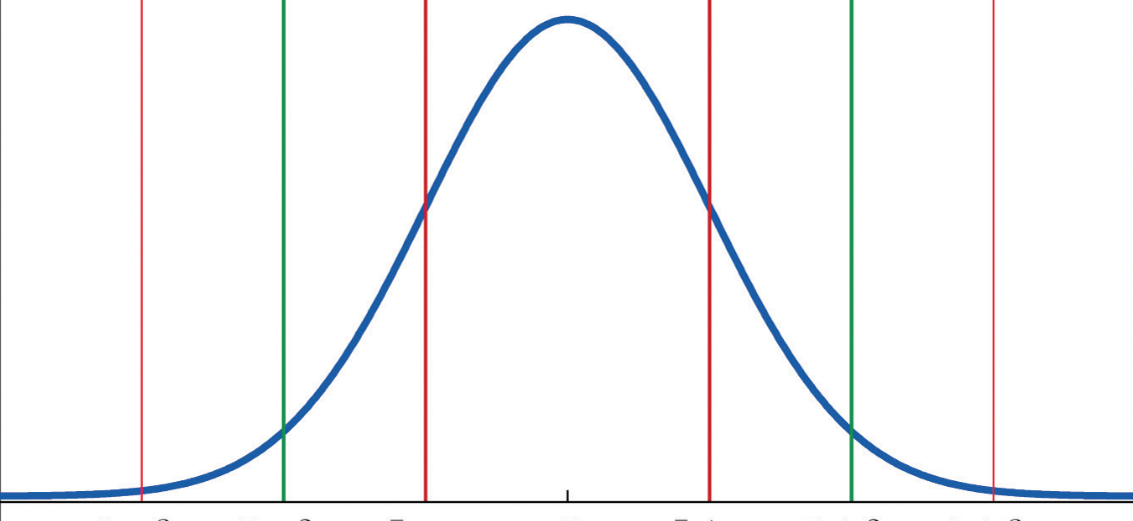

1. What percent of kittens weigh between 2.8 and 4.8 pounds?
2. What percent of kittens weigh more than 2.4 pounds?
3. What value corresponds to the 16th percentile of kitten weights?
4. **An engineer estimates that 22% of produced parts are defective. You are concerned that the percentage is higher. To test this, you collect a random sample of 300 parts and find that 82 of them were defective. Show all the steps of a complete hypothesis test with 5% level of significance (show the population, method, sample, results and conclusion steps). You must show the statistical output.**

**This is the end of your final exam. You do not have to provide your cheat sheet.**